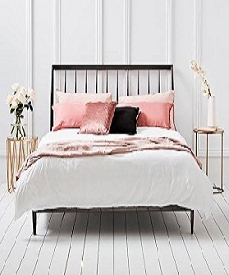

Simple Luxury Bed

$228.75

Availability: In stock

Description

The luxury Bed, part of the Profine Collection, is designed with a lavish modern style in Premium linen upholstery. Ribbed tufted headboard and additional metal legs to ensure stability and support.